3.10

Objectives:

1. Saving boy
2. Treating hemorrhagic fever

Risk:

1. Treating boy by saline solution but boy still die.
2. Treating boy by saline solution and then in trouble with HQ
3. In trouble with HQ and then get court-martialed.

Decision tree.

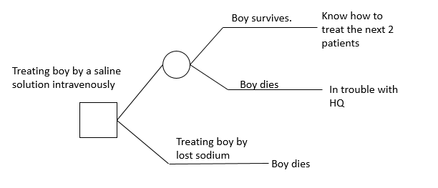

3.16

Main source of the uncertainty：

Is it worth to leave a heavy debt for campaign since the chance of winning had been reduced?

Conflicting objectives:

Cost and chance of winning.

I think he should drop out of the race.

Influence diagram:

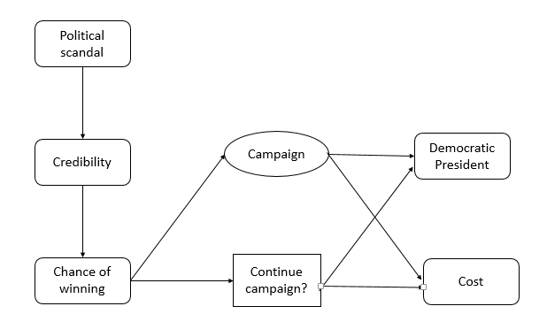

Decision tree:

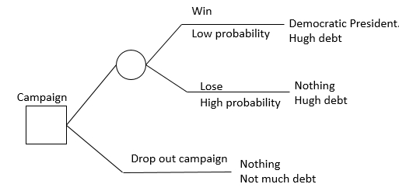

3.23

Fundamental objectives:

1. Safety of Vincennes.
2. Safety of people into the plane.

Risk:

1. Vincennes might be attacked
2. If the plane was not Iranian F-14, people into the plane would die.

Decision Tree:

